Yang Cheat Sheet

Common Errors:

* You forgot a semi-colon! You forgot a closing curly bracket! You forgot to define the type of a leaf! You misspelled something! You forgot your key for a list!

Data Types:

* **Container**: An organizational collection of other data types, which itself contains no data (think a folder directory). Represented in the NSO GUI with a folder symbol, for example:
* 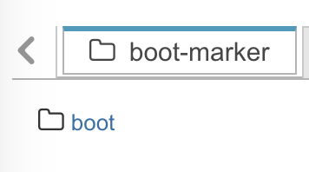
* **Leaf**: a piece of data (also often called a node). Represented in the NSO GUI with a text field, for example:
* 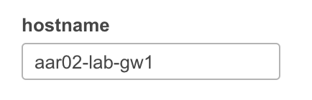
* or multiple leafs:
* 
* **List**: a list of items (think excel spreadsheet), where the lookup key needs to be a unique value. The lookup key can be of any type, but often is a leaf. Represented in the NSO GUI with three horizontal lines, or an spreadsheet like list of entries, for example:
* 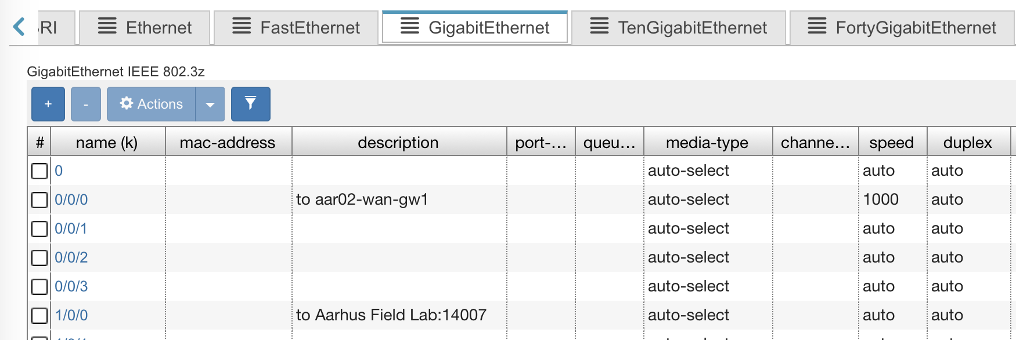
* Note though for interfaces (a common yang model used), the interfaces are in a container and the interface type is a list.